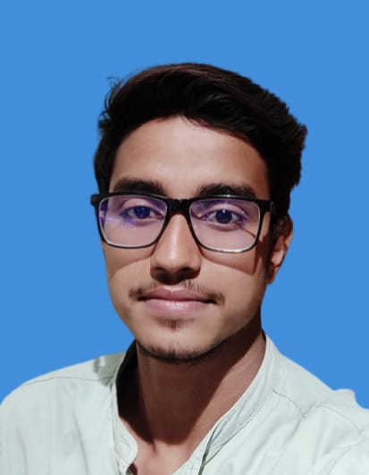



Phone no-6395649060

Email [id-fatherkartennetflix@gmail.com](mailto:id-fatherkartennetflix@gmail.com)

# CAREER OBJECTIVE

HARSHIT SAXENA

Looking for a challenging and task oriented position in an organization which demands the best of my professional ability in terms of managerial and analytical skills and helps me in broadening and enhancing my current skill and knowledge and to be involved as a part of a team that dynamically works towards the growth of the organization and reach the top with determination, dedication and hard work.

OBJECTIVE

Self-motivated and hardworking fresher seeking for an opportunity to work in a challenging environment to prove my skills and utilize my knowledge & intelligence in the growth of the organization

# PROFESSIONAL QUALIFICATION

Pursuing MCA from Invertis University, Bareilly, Uttar Pradesh (2023-2025)

**ACADEMIC PROFILE**

|  |  |  |
| --- | --- | --- |
| **Examination Passed** | **Name of the Institution/ University** | **Month & Year of passing** |
| Pursuing MCA | Invertis University | 2025 |
| BA | Bareilly College Bareilly,  Uttar Pradesh | 2020 - 2023 |
| Intermediate | UP BOARD | 2017 |
| High School | UP BOARD | 2015 |

# EDUCATIONAL QUALIFICATION

* **10th** from Gayatri shiksha peeth inter college , Bareilly in 2015.
* **10+2th** from Vishnu inter college, Bareilly in 2017.

# SIGNIFICANT ACCOMPLISHMENT

* Active participation in **Python code breakers** at Invertis University.
* Active participation in **WEB-RANGER** at Invertis University.

# SOFTWARE SKILLS

* + MS Office, Excel, PowerPoint.
  + WEB TECHNOLOGY, PHYTHON

# STRENGTHS

* Highly confident and innovative in the area of expertise.
* Swift in learning and implementing new topics and techniques.
* Determined to learn with practical approach.
* Good communication skills and managing skills.

# FIELDS OF INTEREST

* Software developer.
* Web developer.
* Case based Studies.
* Data Analytics

# LIGUISTIC PROFICIENCY

* English
* Hindi

# PERSONAL INFORMATION

**Nationality** Indian

**Date of Birth** 7-7-2001

**Gender** Male

**Marital Status** Single

**Permanent Address** 22 Pervez nagar bareilly

**Hobbies** Learning, Writing, playing cricket